Please do spare time & read these instructions before you start filling the form.

Guidelines to Your Background Verification Form

General Instructions:
- PLEASE USE THIS FONT WHILE FILLING THE ENTIRE FORM THROUGH DESKTOP SYSTEMS – CALIBRI; FONT SIZE 11
- Please sign all the pages of this Form including the last one during Joining Formalities.
- Please do mention the contact numbers wherever asked.
- Kindly mention the updated contact numbers & email ids as applicable wherever asked.

Category Specific Instructions:
Personal Details:
- Kindly mention your Full Name in CAPITAL Letters.

Address:
- All the categories are MANDATORY to be filled. Do not leave any category blank.
- Please make sure your complete address with proper landmark is mentioned in permanent as well as current address blocks.

Education:
- Kindly mention all the details of education including the roll numbers/seat numbers/etc.
- Please mention the exact & Full Name & Address of school/college/Institution/organization you have studied in.

Employment Records:
- All the categories are MANDATORY to be filled. Do not leave any category blank.
- Kindly mention the Employment Records in Descending Order – Latest Employment is to be mentioned first.
- Kindly mention “NA” wherever information is absolutely Unavailable / Non-applicable.
- Kindly mentioned the full date of Employment duration & do not leave any of them blank.
- If you were deployed / deputed to other company, then kindly mention the details of only your Parent company on whose payrolls you were employed.
- Please ensure all the contact numbers of Company/Supervisor/HR Manager are updated ones & functional.
- Kindly mention the updated & functional Email Ids wherever asked.
- Please mention the document/documents submitted by you during the Joining Formalities at YASH for the particular Employment as asked.
- Please do mention the current status of the company for the particular employment record.

Reference Verification:
- Kindly make sure that the references are Professional & not Personal/Relatives.

Information Release Form:
- Please write your full name as asked.
- Kindly Sign the form & mention the date on which you are signing it during Joining Formalities.

Employee Code  (To be filled in by HR on Joining) | Employee Location  (To be filled in by HR on Joining)
PERSONAL DETAILS
Full Name of Candidate:
YASH
First

Middle
KHANDELWAL
Surname

Mother’s Maiden Name : KHANDELWAL
Have you ever been known by another name? |  |  YES  NO  If Yes, please write the other name:
Place of Birth: INDORE |  | Date of Birth (dd/mm/yy): 03/01/2005
Gender: MALE |  | Nationality: INDIAN
Father’s Name  SANJAY KHANDELWAL |  | Passport No. | SSN No.  (Mandatory for US address)
Home Phone  9763860234 |  | Office Phone | Mobile  9763860234

RESIDENTIAL ADDRESS

Permanent Address

MAKAN NO 24 WARDNO 10
MAHATMA GANDHI MARG SENDHWA , MADHYA PRADESH

City : SENDHWA | State : MADHYA PRADESH
Pin Code : 451666 | Nearest Landmark : SADAR BAZAR
Name of the contact person at the address : INDU
Relationship of contact person : Mother
Landline No. | Mobile No. 9763860234
Nature Of Location: Rented/Owned/Others  Owned | Preferred time of the day for conducting the verification, if any : 12PM – 5PM
Residing Since (Mandatory):  (2016) | Residing Till ( Mandatory):  (2022)

Current Address
GURUKRIPA NAGAR , 60 FEET ROAD

City : INDORE | State : Madhya Pradesh
Pin : 452002 | Nearest Landmark :
Contact Person at the address : SANJAY
Relationship of contact person : FATHER
Landline No. | Mobile No.
Nature Of Location: Rented/Owned/Others  RENTED | Preferred time of the day for conducting the verification, if any : 12 PM – 5 PM
Residing Since (Mandatory):  (Year) 2024 | Residing Till ( Mandatory):  (Year)2026

Education Record
Education Record (Start with the latest / highest qualification; please attach photocopies of the documents) All fields are mandatory
Name & Address of School/College/Institute | Name & Address of University its affiliated | Type of Degree/Diploma obtained. State “F” for fulltime and “P” for part-time within brackets | Dates Attended  From To |  | Roll Number/Registration Number/Exam Seat number
LIONS CONVENT HR.SEC SCHOOL , SENDHWA | CBSE (NEW DELHI) | AISSCE - F | MARCH 2021 | MARCH 2022 | 19100913
LIONS CONVENT HR.SEC SCHOOL , SENDHWA | CBSE (NEW DELHI) | AISSE - F | MARCH 2019 | MARCH 2020 | 19601123

PROFESSIONAL Education Record

PROFESSIONAL Education Record
(Start with the latest/ highest qualification; please attach photocopies of the documents) All fields are mandatory
Name & Address of School/College/Institute  (Mandatory) | Name & Address of University its affiliated  (Mandatory) | Type of Degree/Diploma obtained. State “F” for fulltime and “P” for part-time within brackets | Dates Attended  From To |  | Roll Number/Registration Number/Exam Seat number
SHRI VAISHNAV VIDYAPEETH VISHWAVIDYALAYA, INDORE | SHRI VAISHNAV VIDYAPEETH VISHWAVIDYALAYA  ,INDORE | BTECH – COMPUTER SCIENCE ENGIENEERING (F) | SEPTEMBER 2022 | JUNE  2026 | 2210DMTCSE12064

Employment RecordS
please mention the records in descending order (Latest employment to be mentioned first)
all the fields are Mandatory to be filled
kindly mention ‘na’ wherever no information is absoltely unavailable/ non-applicable
Employer 1  Full Name of the Company |  | Employee ID | From (dd/mm/yy) | To (dd/mm/yy)
Address |  |  | Phone Number
City | State | Country | Postal Code
Job Title |  | Designation
Reason of Leaving |  | Final Salary (Annual CTC):  Mode of Payment:  Direct Transfer  Cheque  Cash  Others (Please Specify Details)
Supervisor’s -  Name:  Title:  Contact Number:  Email ID: |  | HR Manager’s -  Name:  Contact Number:  Email ID:
Tick Mark The Documents Submitted for this Employment while Joining at YASH:  Offer Letter  Resignation Letter  Resignation Acceptance  Relieving Letter  Service Certificate  Experience Letter  Salary Slips  Full & Final Settlement Document  None |  | Current Status of the Company:  In Existence  Closed  Not Known

Employer 2  Full Name of the Company |  | Employee ID | From (dd/mm/yy) | To (dd/mm/yy)
Address |  |  | Phone Number
City | State | Country | Postal Code
Job Title |  | Designation
Reason of Leaving |  | Final Salary (Annual CTC):  Mode of Payment:  Direct Transfer  Cheque  Cash  Others (Please Specify Details)
Supervisor’s -  Name:  Title:  Contact Number:  Email ID: |  | HR Manager’s -  Name:  Contact Number:  Email ID:
Tick Mark The Documents Submitted for this Employment while Joining at YASH:  Offer Letter  Resignation Letter  Resignation Acceptance  Relieving Letter  Service Certificate  Experience Letter  Salary Slips  Full & Final Settlement Document  None |  | Current Status of the Company:  In Existence  Closed  Not Known

Employer 3  Full Name of the Company |  | Employee ID | From (dd/mm/yy) | To (dd/mm/yy)
Address |  |  | Phone Number
City | State | Country | Postal Code
Job Title |  | Designation
Reason of Leaving |  | Final Salary (Annual CTC):  Mode of Payment:  Direct Transfer  Cheque  Cash  Others (Please Specify Details)
Supervisor’s -  Name:  Title:  Contact Number:  Email ID: |  | HR Manager’s -  Name:  Contact Number:  Email ID:
Tick Mark The Documents Submitted for this Employment while Joining at YASH:  Offer Letter  Resignation Letter  Resignation Acceptance  Relieving Letter  Service Certificate  Experience Letter  Salary Slips  Full & Final Settlement Document  None |  | Current Status of the Company:  In Existence  Closed  Not Known

Employer 4  Full Name of the Company |  | Employee ID | From (dd/mm/yy) | To (dd/mm/yy)
Address |  |  | Phone Number
City | State | Country | Postal Code
Job Title |  | Designation
Reason of Leaving |  | Final Salary (Annual CTC):  Mode of Payment:  Direct Transfer  Cheque  Cash  Others (Please Specify Details)
Supervisor’s -  Name:  Title:  Contact Number:  Email ID: |  | HR Manager’s -  Name:  Contact Number:  Email ID:
Tick Mark The Documents Submitted for this Employment while Joining at YASH:  Offer Letter  Resignation Letter  Resignation Acceptance  Relieving Letter  Service Certificate  Experience Letter  Salary Slips  Full & Final Settlement Document  None |  | Current Status of the Company:  In Existence  Closed  Not Known

reference verification
Note – The reference provided should be currently employed or engaged in a professional activity.

**Please ensure that the contact numbers of the References are active numbers and are reachable for verification.

Kindly provide with the Professional References & not Personal/of relatives.

REFERENCE (1)
Full name of the Reference (Professional) | ANKIT ZALANI
Contact Number | 9993900009
Email ID | INFO.ZALANI@GMAIL.COM
Organization | UNITED ENGINEERS & CO.
Designation | DIRECTOR
Relationship with the candidate | FAMILY FRIEND
REFERENCE (2)
Full name of the Reference (Professional) | VINAYAK KUSHWAH
Contact Number | 6269686084
Email ID | KUSHWAHVINAYAK1@GMAIL.COM
Organization | GAMMAEDGE
Designation | ASSOCIATE SOFTWARE TRAINEE
Relationship with the candidate | CLASSFELLOW
REFERENCE (3)
Full name of the Reference (Professional) | MANISH RAMAWAT
Contact Number | 8103889815
Email ID | MANISHRAMAWAT@YAHOO.CO.IN
Organization | SWATI INDUSTRIES
Designation | DIRECTOR
Relationship with the candidate | FAMILY FRIEND

Other Information
Marital Status: Married / Unmarried / Other

Family Background:
Single (Father, Mother & Sibling details):

Name | Relation | Occupation | Contact Number | Location
SANJAY KHANDELWAL | FATHER | BUSINESS | 9329459578 | INDORE
INDU KHANDELWAL | MOTHER | HOMEMAKER | 9763860234 | INDORE

Married (Father, Mother, Wife & Children details):

Name | Relation | Occupation | Contact Number | Location

Do you have a Bond with your current employer? If yes, please give details of the time period, amount and any other relevant details.
NO

If you have any relatives / friends / acquaintances in this company working at present or in the past, please give details.

Name | Department/Technology | Relationship | Contact Number
RAVIRAJ PRASAD | PYTHON INTERN | FRIEND | 9601802655
BHAVYA JAIN | PYTHON INTERN | FRIEND | 9826036102

Awards / Achievements or Special Comments:

NA

Areas of Interest:

AIML,JAVA

Do you posses any technical certification/ training? (Specify):

IBM GENERATIVE AI VIRTUAL INTERNSHIP

CURRENT EMOLUMENTS

Please list out all the perquisites, which can be measured monetarily including those benefits that may be once in 2-3 years also.

Elements Of Compensation  of  c  o  mpensat  ion | Details | Annual
Elements Of Compensation  of  c  o  mpensat  ion | Basic
Elements Of Compensation  of  c  o  mpensat  ion | House Rent Allowance
Elements Of Compensation  of  c  o  mpensat  ion | Special Allowance
Elements Of Compensation  of  c  o  mpensat  ion | Conveyance
Elements Of Compensation  of  c  o  mpensat  ion | Leave Travel Assistance
Elements Of Compensation  of  c  o  mpensat  ion | Medical Reimbursement
Elements Of Compensation  of  c  o  mpensat  ion | Medical Insurance
Elements Of Compensation  of  c  o  mpensat  ion | Provident Fund
Elements Of Compensation  of  c  o  mpensat  ion | Superannuation
Elements Of Compensation  of  c  o  mpensat  ion | Gratuity
Elements Of Compensation  of  c  o  mpensat  ion | Any other Benefits/ Perks (Please Specify)
Elements Of Compensation  of  c  o  mpensat  ion | Performance Bonus
 | TOTAL
 | Last Appraisal Month/Year
 | % Hike in present Company for last appraisal

Information Release Form
To Whom It May Concern:

Please print
I KHANDELWAL YASH _______________________________________________________________________
Last name First name Middle name

I hereby authorize KPMG or their representatives to verify information presented on my employment application/resume and to procure an investigative report or consumer report for that purpose.
I hereby grant authority for the bearer of this letter to access or be provided with full details
- of my previous employment record held by any company or business for whom I previously worked. This information should include the dates of employment; the nature of the position held, [details of my salary upon departure] and an appraisal of my performance, capabilities and character. In addition, please provide any other pertinent information requested by the individual presenting this authority. I hereby release from liability all persons or entities requesting or supplying such information.
- of my qualification/degree (copy of my certificates attached)
- information in respect to my character from the records maintained by local authorities

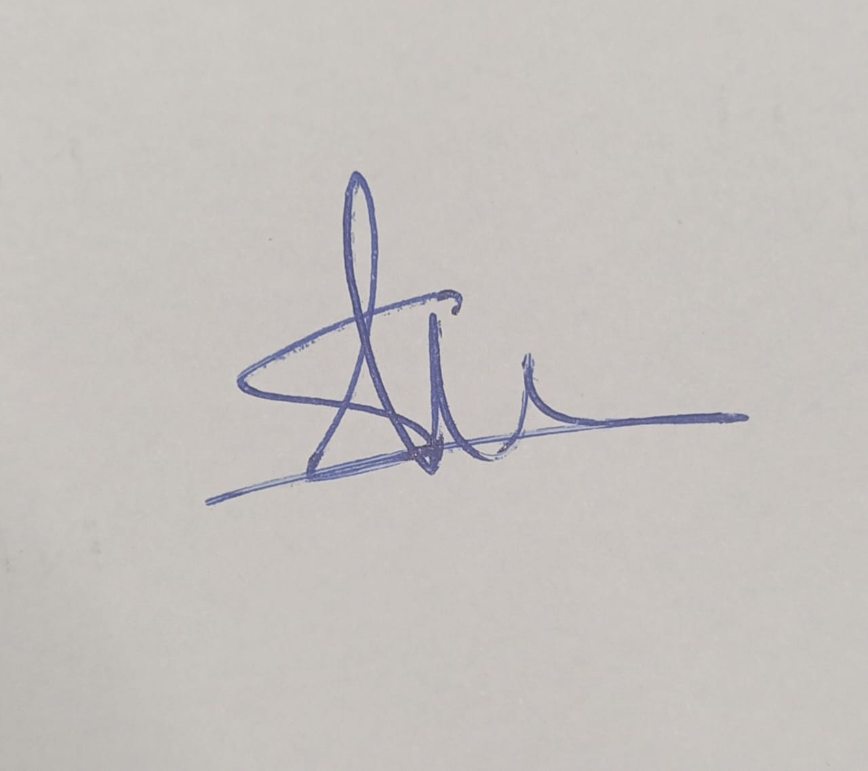 |  | 18/03/2026
Signature: |  | Date: dd / mm / yyyy

